**An Analysis of Trends in the Canadian Housing Market**

Ronald Garcia, Anton Katipunan, Emily McClellan, Vida Rahmani and Jagjeet Rathore

Group 7

Data Science 1: Foundations of Data Science

August 10, 2020

**An Analysis of Trends in the Canadian Housing Market**

The housing market is often covered by mainstream media with respect to housing prices and the health of the industry. Trends in the housing market are analyzed closely because they are viewed as indicators for consumer confidence and, subsequently, the health of the economy. Unfortunately, this media coverage can be subject to bias if the source used to identify trends is an industry stakeholder, such as a real estate agent or mortgage broker. These parties may be using their opportunities in the media to instill confidence or spur fears to prompt business. For instance, an article on CBC.ca dated August 9, 2019 cites the Toronto Real Estate Board (“TREB”) CEO stating that “there's a growing demand for residential properties due to population growth,” yet fails to reference actual trends in population growth that could be driving demand. TREB is a non-profit organization comprised of realtors who collect fees from real estate transaction. After reading a statement such as that made by the TREB CEO, potential home owners may be compelled to accelerate their pursuit of a new home.This report seeks to characterize the current state of the Canadian housing market by exploring demographic trends that impact demand, how such trends have influenced home ownership and, lastly, how the financial circumstances of Canadians have been affected.

**Objectives**

**Demographic Trends**

Canadian demographics continue to evolve and immigration is perennial driver of change. How has immigration affected population growth in major markets, and how have house prices changed in those markets? In these ever-growing cities, how does household income compare to housing prices (i.e. affordability)? Have families themselves changed in these cities (e.g. are couples having less children)?

**Home Ownership**

As housing prices increase, potential home owners may be seeking alternatives. How has the rental market changed over time? How are first-time home buyers characterized?

**Financial Impacts**

Given the rising costs of homes, it stands to reason that mortgages have followed suit since income levels have not grown at the same pace. How have mortgages changed over time?

**Data Sources**

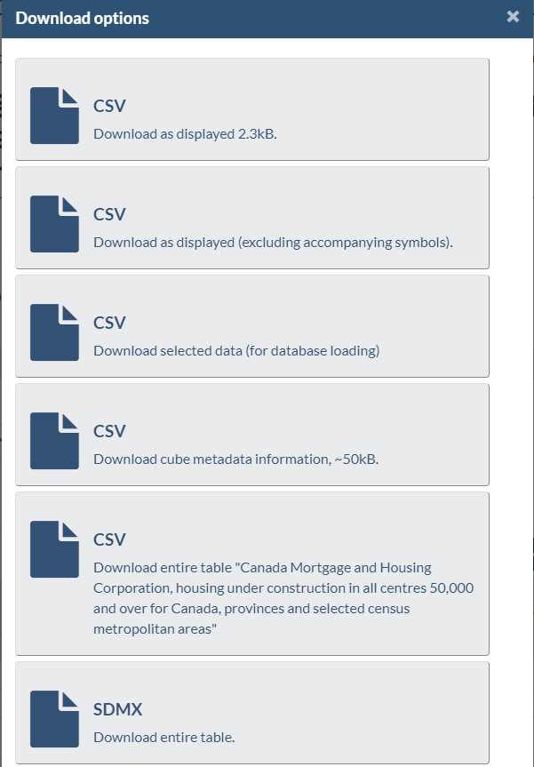Statistics Canada (“Statcan”) is the primary source for the datasets used in this analysis. Statcan provides data on Population, Immigration, Family Composition, Housing Prices, Vacancy Rates, etc. The Canadian Mortgage and Housing Corporation (“CMHC”) provides a dataset for Median Household Income. To capture trends, this analysis uses datasets that span at least ten years where possible.

Figure 1 - Statcan Download Options

The data was collected by searching the Statcan website for housing topics. Once a dataset was found, it was filtered for the desired time period and necessary fields. Fortunately, Statcan provides a number of download options for its data. The data was downloaded using the third option (for database loading). In terms of structure, the data quality was very good.

The following datasets are utilized in this analysis:

Population estimates, July 1, by census metropolitan area, 2009-2019 (“Population Estimates”)

[NTD: Add description of tools used to prepare the data]

**Challenges**

The main challenge in searching for appropriate datasets is finding data that capture the same time period. Statcan did not collect data for certain aspects of the housing market until recently, such as first-time home buyer demographics. As one would expect, historical population and income data is readily available. However, another challenge is encountered as the frequency at which this data is collected differs from other datasets (i.e. every four years versus annually).

**Analysis**

The Canadian marketplace can be examined through the lens of its six major consumer markets: Vancouver; Edmonton; Calgary; Toronto; Ottawa; and, Montreal. These cities capture a significant portion of Canada’s population. However, the scope of our analysis will capture three of these cities for simplicity and ease of identifying recognizable trends. As such, this report focuses on Toronto, Vancouver and Calgary. Toronto is the most populous metropolitan city in Canada and the trends occurring at a municipal level contribute greatly at a national level. Vancouver, while only third in terms of population size, is the most expensive housing market in Canada. In fact, according to CBRE’s Global Living 2019 report, Vancouver is the fourth most expensive housing market in world behind Hong Kong, Singapore and Shanghai (Toronto ranks 12th). Calgary was selected as a contrast to Toronto and Vancouver given that its economy, and consequently its housing market, are driven primarily by the oil and gas industry.

**Demographic Trends**

***Population***

Examining the Population Estimates data reveals that there is, in fact, population growth as the TREB CEO succinctly stated. However, the *rate of growth* has varied drastically between 2009 and 2019 for the VECTOM markets, as shown in Figure 2.

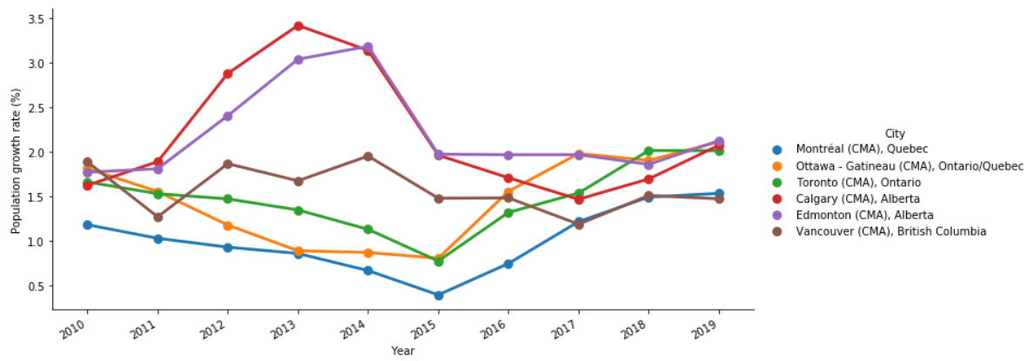

Figure 2 - Population Growth Rates, VECTOM

Once again, an uninformed reader of the aforementioned CBC.ca article might identify ‘population growth’ with a persistent upward trend in growth rate. As Figure 2 shows, the growth rates for VECTOM markets has gradually progressed to stabilization since 2015, settling between 1.5% to 2.0%. Toronto has grown the fastest between 2015 and 2019. Calgary experienced rapid growth between 2011 and 2013 and a subsequent rapid decrease from 2013 to 2015, a response linked to the oil industry (Edmonton suffered the same fate). Vancouver’s growth rate has remained relatively stable, likely because the city has a more limited geography given its mountainous surroundings, and potentially due to its ever-increasing housing prices.

***Immigration***

[NTD: Add analysis, can’t open file]

***Household Income***

[NTD: Add analysis, Emily to complete]

***Family Composition***

[NTD: Add analysis, Jagjeet to update]

**Home Ownership**

***House Prices***

In Toronto and Vancouver, there has been a persistent upward trend in Condominium prices since Q1 2017. Vancouver has reached a more stabilized level, while Toronto has not shown any evidence of stabilization. Meanwhile, Condominium prices in Calgary have been steadily decreasing in the same time period.

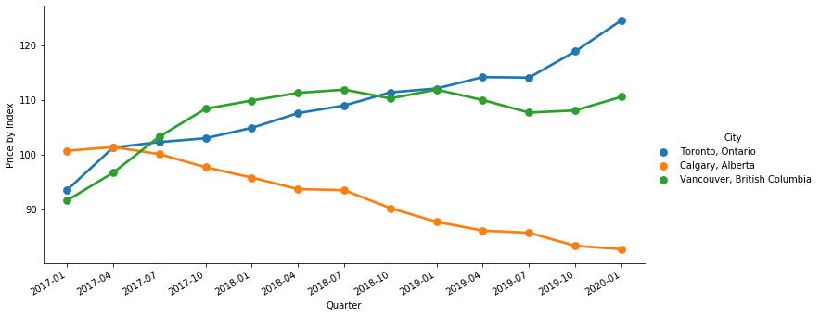

House prices peaked between 2017 and 2018 in Vancouver and Toronto and experienced a slight decline since then. However, they have gradually recovered and are close to 2017 levels once again. Calgary house prices decreased, unsurprisingly, however not at the same pace as condominium prices.

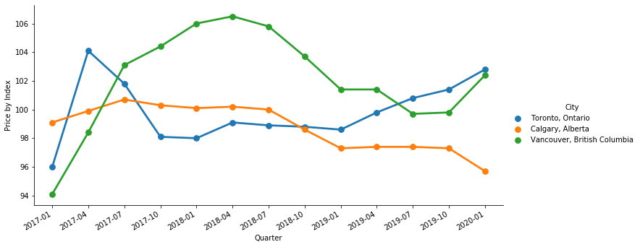

***Rental Market***

Vancouver and Toronto have shown steady declines in vacancy rates since 2009. This signifies a strong demand for housing. Calgary has experienced a completely opposite trend, with vacancy spiking in 2016 due to a lack of demand. Calgary actually had a lower vacancy rate than Vancouver and Toronto for a brief period between 2011 and 2014, but once again became victim to the swings of the oil industry. By 2019, Calgary's vacancy rate improved since its 2009 levels.

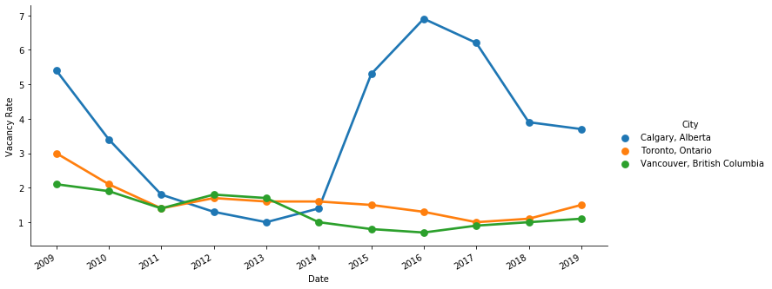

***First-Time Home Buyers***

**Financial Impacts**

***Mortgage Trends***

**Conclusion**

**References**

<https://www.cbc.ca/news/canada/toronto/toronto-home-sales-1.5237143>

<https://www.cbreresidential.com/uk/sites/uk-residential/files/property-info/FINAL%20REPORT.pdf>